Production environment

🗂️ What Is Production environment?
# Source: AI Source: Provided by: [Data Path: Persons Table -> ID Column: 1, Name_En Column: Motasem Essam] -> From: [ChatGPT] on [1/26/2026]
A production environment is the live environment where the application is actually used by real users.
This is the real deal — anything that breaks here affects customers.

What production is for
# Source: AI Source: Provided by: [Data Path: Persons Table -> ID Column: 1, Name_En Column: Motasem Essam] -> From: [ChatGPT] on [1/26/2026]
Production is where you:
- Serve real users
- Process real data
- Handle real payments, emails, and traffic
- Run the official, released version of the app

Key characteristics
# Source: AI Source: Provided by: [Data Path: Persons Table -> ID Column: 1, Name_En Column: Motasem Essam] -> From: [ChatGPT] on [1/26/2026]
A production environment typically has:
- 👥 Real users
- 🗄️ Real, permanent data
- 🔐 Real secrets & credentials (securely managed)
- 🚫 Debugging OFF (no detailed error messages)
- 📊 Monitoring & logging ON
- ⚡ High performance & reliability
- 🔒 Strict security rules

Example configuration
# Source: AI Source: Provided by: [Data Path: Persons Table -> ID Column: 1, Name_En Column: Motasem Essam] -> From: [ChatGPT] on [1/26/2026]
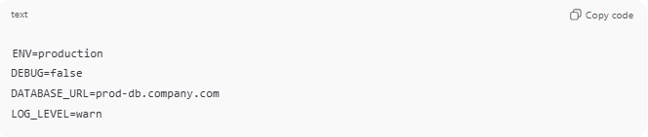
ENV=production
DEBUG=false
DATABASE_URL=prod-db.company.com
LOG_LEVEL=warn

How it compares to other environments
# Source: AI Source: Provided by: [Data Path: Persons Table -> ID Column: 1, Name_En Column: Motasem Essam] -> From: [ChatGPT] on [1/26/2026]
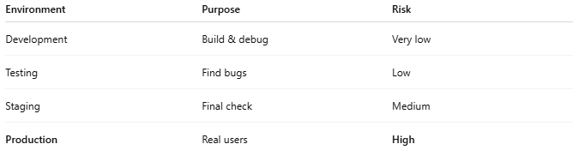
Environment | Purpose | Risk
Development | Build & debug | Very low
Testing | Find bugs | Low
Staging | Final check | Medium
Production | Real users | High

Why production is handled carefully
# Source: AI Source: Provided by: [Data Path: Persons Table -> ID Column: 1, Name_En Column: Motasem Essam] -> From: [ChatGPT] on [1/26/2026]
- Bugs = user impact
- Data loss = serious consequences
- Downtime = lost trust and money
That’s why teams use:
- Code reviews
- CI/CD pipelines
- Rollbacks
- Feature flags
- Monitoring & alerts

Real-world analogy
# Source: AI Source: Provided by: [Data Path: Persons Table -> ID Column: 1, Name_En Column: Motasem Essam] -> From: [ChatGPT] on [1/26/2026]
Production is like:
A store open to customers
No experiments, no mess — everything must work.

